Elsevier, Springer, Wiley, and Nature
Payment History for Journal Packages at the University of Wyoming
July 28, 2014

On the second page of this document, payment information for the Elsevier Freedom Collection, Springer E-Journal package, and Wiley (formerly Wiley-Blackwell) E-Journal package is displayed. The screen shots were taken from the University of Wyoming’s Sierra integrated library system on July 28, 2014. The University of Wyoming does not have a subscription to the Nature e-journal package, so there is not a screen shot for that package.

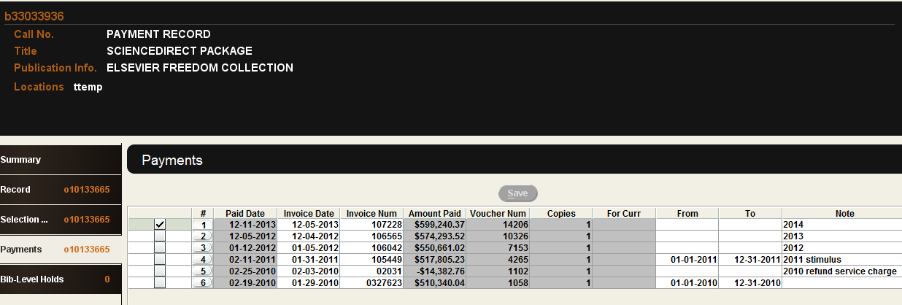

Elsevier Freedom Collection Payment Record from Sierra

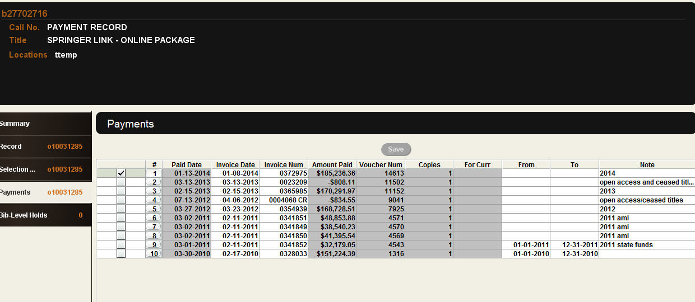

Springer Payment Record from Sierra

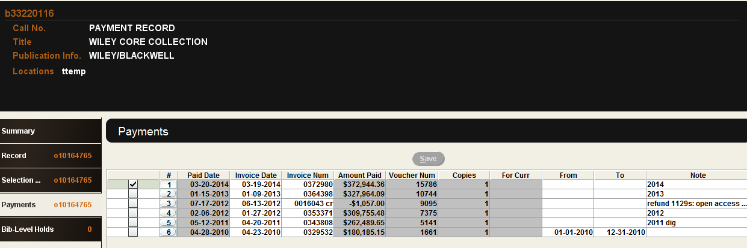

Wiley Payment Record from Sierra

